ACKNOWLEDGEMENT

We would like to express our deepest appreciation to all those who provided us the possibility to complete this report. A special gratitude we give to Mr. Kamlesh Kumar whose contribution in stimulating suggestions and encouragement, helped us to coordinate our project especially in writing this report. Furthermore, we would also like to acknowledge with much appreciation the crucial role of the staff of B.I.ET, who gave the permission to use all required equipment and the necessary materials to complete the task. We are thankful and fortunate enough to get constant support from our seniors and every teaching staff of B.Tech department which helped us successfully complete our project. We would also like to extend our regards to all the non-teaching staff of B.Tech department for their timely support. We have to appreciate the guidance given by other supervisor as well as the panels especially in our project presentation that has improved our presentation skills thanks to their comment and advices. Our thanks and appreciations also go to each and every one of our colleagues for their encouragement and support in developing the project.

ABSTRACT

The purpose of Anwi Beauty Parlour is to automate the existing manual system by the help of computerized equipments and full-fledged computer software, fulfilling their requirements, so that their valuable data/information can be stored for a longer period with easy accessing and manipulation of the same. The required software and hardware are easily available and easy to work with.
Anwi Beauty Parlour, as described above, can lead to error free, secure, reliable and fast management system. It can assist the user to concentrate on their other activities rather to concentrate on the record keeping. Thus it will help organization in better utilization of resources. The organization can maintain computerized records without redundant entries. That means that one need not be distracted by information that is not relevant, while being able to reach the information.
The aim is to automate its existing manual system by the help of computerized equipments and full-fledged computer software, fulfilling their requirements, so that their valuable data/information can be stored for a longer period with easy accessing and manipulation of the same. Basically the project describes how to manage for good performance and better services for the clients.

Introduction of the Project Anwi Beauty Parlour:

Beauty parlor management system is a web-based salon management application with appointment scheduling functionality. In this system user can review salons and stylist online and can make appointment online. In this system beauty parlor owner can make their account online and give details of the services they offer and also describe the stylist information. User can review the salons and their services using this system and can make appointment with favorite stylist online. User can also cancel appointments online. User can also write and reviews about the salon or stylist. This system helps both the customer and the salon. Customer can easily find best salon in their locality and can check the review of other customer of that salon online. It helps him to take decision of taking the services of a particular salon.

Purpose Of The Anwi Beauty Parlour Project:

- Provide a Single environment from where an administrator can interact with the beauty shop system resources with in the beauty center network.
- Provides Info regarding the beauty parlor no of services running on the beauty center system.
- To provide an upgrade support for the beauty shop system resources.
- Provides interface to interact with the beauty shop system parameters like network settings, OS Settings, Services, and Process etc.
- Provides means of reporting the beauty parlor system setting to a person through email.
- There by an administrator can know the status of a systems throughout the network

Modules of Anwi Beauty Parlour:
- Home
- Services
- Offers
- Book Appointment
- Contact Us

Source Code of Anwi Beauty Parlour:

Index.html file:
<!doctype html>
<html lang="en">

<head>
<!-- Required meta tags -->
<meta charset="utf-8">
<meta name="viewport" content="width=device-width, initial-scale=1, shrink-to-fit=no">
<!-- For Instra -->
<link rel="stylesheet" href="https://cdnjs.cloudflare.com/ajax/libs/font-awesome/4.7.0/css/font-awesome.min.css">
<!-- Bootstrap CSS -->
<link rel="stylesheet" href="https://maxcdn.bootstrapcdn.com/bootstrap/4.0.0/css/bootstrap.min.css"
integrity="sha384-Gn5384xqQ1aoWXA+058RXPxPg6fy4IWvTNh0E263XmFcJlSAwiGgFAW/dAiS6JXm" crossorigin="anonymous">

<title>Welcome to Anwi Beauty Parlour</title>
</head>

<body>
<nav class="navbar navbar-expand-lg navbar-dark bg-dark">
<a class="navbar-brand" href="index.html">Anwi Beauty Parlour</a>
<button class="navbar-toggler" type="button" data-toggle="collapse" data-target="#navbarSupportedContent"
aria-controls="navbarSupportedContent" aria-expanded="false" aria-label="Toggle navigation">
<span class="navbar-toggler-icon"></span>
</button>

<div class="collapse navbar-collapse" id="navbarSupportedContent">
<ul class="navbar-nav mr-auto">
<li class="nav-item active">
<a class="nav-link" href="index.html">Home <span class="sr-only">(current)</span></a>
</li>
<li class="nav-item">
<a class="nav-link" href="services.html">Services</a>
</li>
<li class="nav-item">
<a class="nav-link" href="offers.html">Offers</a>
</li>
<li class="nav-item">
<a class="nav-link" href="appointment.html">Book Appointment</a>
</li>
<li class="nav-item">
<a class="nav-link" href="contact.html">Contact Us</a>
</li>

</div>
</nav>
<!-- slider -->
<div id="carouselExampleIndicators" class="carousel slide" data-ride="carousel">
<ol class="carousel-indicators">
<li data-target="#carouselExampleIndicators" data-slide-to="0" class="active"></li>
<li data-target="#carouselExampleIndicators" data-slide-to="1"></li>
<li data-target="#carouselExampleIndicators" data-slide-to="2"></li>
</ol>
<div class="carousel-inner">
<div class="carousel-item active">
<img class="d-block w-100" src="images\home\slider3.jpg" alt="First slide">
</div>
<div class="carousel-item">
<img class="d-block w-100" src="images\home\slider1.jpg" alt="Second slide">
</div>
<div class="carousel-item">
<img class="d-block w-100" src="images\home\slider2.jpg" alt="Third slide">
</div>
</div>
<a class="carousel-control-prev" href="#carouselExampleIndicators" role="button" data-slide="prev">
<span class="carousel-control-prev-icon" aria-hidden="true"></span>
<span class="sr-only">Previous</span>
</a>
<a class="carousel-control-next" href="#carouselExampleIndicators" role="button" data-slide="next">
<span class="carousel-control-next-icon" aria-hidden="true"></span>
<span class="sr-only">Next</span>
</a>
</div>
<hr>
<div class="card-deck">
<div class="card">
<img class="card-img-top" src="images\home\gallery1.jpg" alt="Card image cap">
<div class="card-body">
<h5 class="card-title">Facial Treatments</h5>
</div>
<div class="card-footer">
<a href="appointment.html" class="btn btn-primary">Book Appointment </a>
</div>
</div>
<div class="card">
<img class="card-img-top" src="images\home\gallery2.jpg" alt="Card image cap">
<div class="card-body">
<h5 class="card-title">Manicure</h5>
</div>
<div class="card-footer">
<a href="appointment.html" class="btn btn-primary">Book Appointment </a>
</div>
</div>
<div class="card">
<img class="card-img-top" src="images\home\gallery3.jpg" alt="Card image cap">
<div class="card-body">
<h5 class="card-title">Hair Care</h5>
</div>
<div class="card-footer">
<a href="appointment.html" class="btn btn-primary">Book Appointment </a>
</div>
</div>
<div class="card">
<img class="card-img-top" src="images\home\gallery4.jpg" alt="Card image cap">
<div class="card-body">
<h5 class="card-title">Threading</h5>
</div>
<div class="card-footer">
<a href="appointment.html" class="btn btn-primary">Book Appointment </a>
</div>
</div>
<div class="card">
<img class="card-img-top" src="images\home\gallery5.jpg" alt="Card image cap">
<div class="card-body">
<h5 class="card-title">Pedicure</h5>
</div>
<div class="card-footer">
<a href="appointment.html" class="btn btn-primary">Book Appointment </a>
</div>
</div>

</div>
<!-- Footer -->
<br>
<div class="card text-center">
<div class="card-header">
<b>Copyright:Anwi Beauty Parlour</b>
</div>
<div class="card-body">
<h5 class="card-title"></h5>
<p class="card-text">Use full links</p>
<button type="button" class="btn btn-outline-primary"><a href=""><i class="fa fa-instagram"></i>
Instagram</a></button>
<button type="button" class="btn btn-outline-secondary"><a href=""><i class="fa fa-whatsapp"></i>
Whatsapp</a></button>
<button type="button" class="btn btn-outline-danger"><a href=""><i class="fa fa-facebook-official"></i>
Facebook</a></button>
</div>
</div>
<!-- Optional JavaScript -->
<!-- jQuery first, then Popper.js, then Bootstrap JS -->
<script src="https://code.jquery.com/jquery-3.2.1.slim.min.js"
integrity="sha384-KJ3o2DKtIkvYIK3UENzmM7KCkRr/rE9/Qpg6aAZGJwFDMVNA/GpGFF93hXpG5KkN"
crossorigin="anonymous"></script>
<script src="https://cdnjs.cloudflare.com/ajax/libs/popper.js/1.12.9/umd/popper.min.js"
integrity="sha384-ApNbgh9B+Y1QKtv3Rn7W3mgPxhU9K/ScQsAP7hUibX39j7fakFPskvXusvfa0b4Q"
crossorigin="anonymous"></script>
<script src="https://maxcdn.bootstrapcdn.com/bootstrap/4.0.0/js/bootstrap.min.js"
integrity="sha384-JZR6Spejh4U02d8jOt6vLEHfe/JQGiRRSQQxSfFWpi1MquVdAyjUar5+76PVCmYl"
crossorigin="anonymous"></script>
</body>

</html>

services.html file:

<!doctype html>
<html lang="en">

<head>
<!-- Required meta tags -->
<meta charset="utf-8">
<meta name="viewport" content="width=device-width, initial-scale=1, shrink-to-fit=no">

<!-- For Instra -->
<link rel="stylesheet" href="https://cdnjs.cloudflare.com/ajax/libs/font-awesome/4.7.0/css/font-awesome.min.css">
<!-- Bootstrap CSS -->
<link rel="stylesheet" href="https://maxcdn.bootstrapcdn.com/bootstrap/4.0.0/css/bootstrap.min.css"
integrity="sha384-Gn5384xqQ1aoWXA+058RXPxPg6fy4IWvTNh0E263XmFcJlSAwiGgFAW/dAiS6JXm" crossorigin="anonymous">

<title>Services</title>
</head>

<body>
<nav class="navbar navbar-expand-lg navbar-dark bg-dark">
<a class="navbar-brand" href="index.html">Anwi Beauty Parlour</a>
<button class="navbar-toggler" type="button" data-toggle="collapse" data-target="#navbarSupportedContent"
aria-controls="navbarSupportedContent" aria-expanded="false" aria-label="Toggle navigation">
<span class="navbar-toggler-icon"></span>
</button>

<div class="collapse navbar-collapse" id="navbarSupportedContent">
<ul class="navbar-nav mr-auto">
<li class="nav-item">
<a class="nav-link" href="index.html">Home <span class="sr-only">(current)</span></a>
</li>
<li class="nav-item">
<a class="nav-link active" href="services.html">Services</a>
</li>
<li class="nav-item">
<a class="nav-link" href="offers.html">Offers</a>
</li>
<li class="nav-item">
<a class="nav-link" href="appointment.html">Book Appointment</a>
</li>
<li class="nav-item">
<a class="nav-link" href="contact.html">Contact Us</a>
</li>

</div>
</nav>
<hr>
<div class="container">
<h1> Hair services</h1>
<table class="table">
<thead>
<tr>
<th scope="col">Type</th>
<th scope="col">Price Range</th>
</tr>
</thead>
<tbody>
<tr>
<td scope="row">Hair Cut</td>
<td scope="row">200-400</td>
</tr>
<tr>
<td scope="row">Wash only</td>
<td scope="row">250-500</td>
</tr>
<tr>
<td scope="row">Straightening & Smoothening </td>
<td scope="row">300-500</td>
</tr>
<tr>
<td scope="row">Styling </td>
<td scope="row">100-200</td>
</tr>
<tr>
<td scope="row">Curling </td>
<td scope="row">1300-1500</td>
</tr>
</tbody>
</table>
<hr>
<br>
<h1>Waxing</h1>
<table class="table">
<thead>
<tr>
<th scope="col">Type</th>
<th scope="col">Price Range</th>
</tr>
</thead>
<tbody>
<tr>
<td scope="row">Face</td>
<td scope="row">200-400</td>
</tr>
<tr>
<td scope="row">Hands</td>
<td scope="row">250-500</td>
</tr>
<tr>
<td scope="row">Legs</td>
<td scope="row">300-500</td>
</tr>
<tr>
<td scope="row">Under Arms</td>
<td scope="row">100-200</td>
</tr>
<tr>
<td scope="row">Full Body</td>
<td scope="row">1300-1500</td>
</tr>
</tbody>
</table>
<br>
<h1>Other</h1>
<table class="table">
<thead>
<tr>
<th scope="col">Type</th>
<th scope="col">Price Range</th>
</tr>
</thead>
<tbody>
<tr>
<td scope="row">Manicure</td>
<td scope="row">200-400</td>
</tr>
<tr>
<td scope="row">Pedicure</td>
<td scope="row">250-500</td>
</tr>
<tr>
<td scope="row">Facials</td>
<td scope="row">300-500</td>
</tr>
<tr>
<td scope="row">Threading </td>
<td scope="row">100-200</td>
</tr>
</tbody>
</table>
<br>
<a href="appointment.html"><button class="btn btn-primary btn-lg">Book Appointment
Now</button></a>
</div>
<!-- Footer -->
<br>
<div class="card text-center">
<div class="card-header">
<b>Copyright:Anwi Beauty Parlour</b>
</div>
<div class="card-body">
<h5 class="card-title"></h5>
<p class="card-text">Use full links</p>
<button type="button" class="btn btn-outline-primary"><a href=""><i class="fa fa-instagram"></i>
Instagram</a></button>
<button type="button" class="btn btn-outline-secondary"><a href=""><i class="fa fa-whatsapp"></i>
Whatsapp</a></button>
<button type="button" class="btn btn-outline-danger"><a href=""><i class="fa fa-facebook-official"></i>
Facebook</a></button>
</div>
</div>
<!-- Optional JavaScript -->
<!-- jQuery first, then Popper.js, then Bootstrap JS -->
<script src="https://code.jquery.com/jquery-3.2.1.slim.min.js"
integrity="sha384-KJ3o2DKtIkvYIK3UENzmM7KCkRr/rE9/Qpg6aAZGJwFDMVNA/GpGFF93hXpG5KkN"
crossorigin="anonymous"></script>
<script src="https://cdnjs.cloudflare.com/ajax/libs/popper.js/1.12.9/umd/popper.min.js"
integrity="sha384-ApNbgh9B+Y1QKtv3Rn7W3mgPxhU9K/ScQsAP7hUibX39j7fakFPskvXusvfa0b4Q"
crossorigin="anonymous"></script>
<script src="https://maxcdn.bootstrapcdn.com/bootstrap/4.0.0/js/bootstrap.min.js"
integrity="sha384-JZR6Spejh4U02d8jOt6vLEHfe/JQGiRRSQQxSfFWpi1MquVdAyjUar5+76PVCmYl"
crossorigin="anonymous"></script>
</body>

</html>

Offers.html file:
<!doctype html>
<html lang="en">

<head>
<!-- Required meta tags -->
<meta charset="utf-8">
<meta name="viewport" content="width=device-width, initial-scale=1, shrink-to-fit=no">

<!-- For Instra -->
<link rel="stylesheet" href="https://cdnjs.cloudflare.com/ajax/libs/font-awesome/4.7.0/css/font-awesome.min.css">
<!-- Bootstrap CSS -->
<link rel="stylesheet" href="https://maxcdn.bootstrapcdn.com/bootstrap/4.0.0/css/bootstrap.min.css"
integrity="sha384-Gn5384xqQ1aoWXA+058RXPxPg6fy4IWvTNh0E263XmFcJlSAwiGgFAW/dAiS6JXm" crossorigin="anonymous">
<title>Offers</title>
</head>

<body>
<nav class="navbar navbar-expand-lg navbar-dark bg-dark">
<a class="navbar-brand" href="index.html">Anwi Beauty Parlour</a>
<button class="navbar-toggler" type="button" data-toggle="collapse" data-target="#navbarSupportedContent"
aria-controls="navbarSupportedContent" aria-expanded="false" aria-label="Toggle navigation">
<span class="navbar-toggler-icon"></span>
</button>

<div class="collapse navbar-collapse" id="navbarSupportedContent">
<ul class="navbar-nav mr-auto">
<li class="nav-item">
<a class="nav-link" href="index.html">Home <span class="sr-only">(current)</span></a>
</li>
<li class="nav-item">
<a class="nav-link" href="services.html">Services</a>
</li>
<li class="nav-item active">
<a class="nav-link" href="offers.html">Offers</a>
</li>
<li class="nav-item">
<a class="nav-link" href="appointment.html">Book Appointment</a>
</li>
<li class="nav-item">
<a class="nav-link" href="contact.html">Contact Us</a>
</li>

</div>
</nav>
<hr>
<div class="card-deck">
<div class="card">
<img class="card-img-top" src="images\offers\hair-4110634_1280.jpg" alt="Card image cap">
<div class="card-body">
<h5 class="card-title">Up to 15% of on Hair services</h5>
<a href="appointment.html" class="btn btn-primary">Book Appointment </a>
<!-- <p class="card-text">This is a wider card with supporting text below as a natural lead-in to additional
content. This content is a little bit longer.</p> -->
</div>
<div class="card-footer">
<small class="text-muted">Offers Expire in 3 days</small>
</div>
</div>
<div class="card">
<img class="card-img-top" src="images\offers\raphael-lovaski-Pe9IXUuC6QU-unsplash.jpg" alt="Card image cap">
<div class="card-body">
<h5 class="card-title">Up to 20% of on Waxing</h5>
<a href="appointment.html" class="btn btn-primary">Book Appointment </a>
<!-- <p class="card-text">This card has supporting text below as a natural lead-in to additional content.</p> -->
</div>
<div class="card-footer">
<small class="text-muted">Offers Expire in 3 days</small>
</div>
</div>
<div class="card">
<img class="card-img-top" src="images\offers\freestocks-AFvUO61NlOU-unsplash.jpg" alt="Card image cap">
<div class="card-body">
<h5 class="card-title">Up to 35% of on Other Services</h5>
<a href="appointment.html" class="btn btn-primary">Book Appointment </a>
<!-- <p class="card-text">This is a wider card with supporting text below as a natural lead-in to additional
content. This card has even longer content than the first to show that equal height action.</p> -->
</div>
<div class="card-footer">
<small class="text-muted">Offers Expire in 3 days</small>
</div>
</div>
</div>
<!-- Footer -->
<br>
<div class="card text-center">
<div class="card-header">
<b>Copyright:Anwi Beauty Parlour</b>
</div>
<div class="card-body">
<h5 class="card-title"></h5>
<p class="card-text">Use full links</p>
<button type="button" class="btn btn-outline-primary"><a href=""><i class="fa fa-instagram"></i>
Instagram</a></button>
<button type="button" class="btn btn-outline-secondary"><a href=""><i class="fa fa-whatsapp"></i>
Whatsapp</a></button>
<button type="button" class="btn btn-outline-danger"><a href=""><i class="fa fa-facebook-official"></i>
Facebook</a></button>
</div>
</div>
<!-- Optional JavaScript -->
<!-- jQuery first, then Popper.js, then Bootstrap JS -->
<script src="https://code.jquery.com/jquery-3.2.1.slim.min.js"
integrity="sha384-KJ3o2DKtIkvYIK3UENzmM7KCkRr/rE9/Qpg6aAZGJwFDMVNA/GpGFF93hXpG5KkN"
crossorigin="anonymous"></script>
<script src="https://cdnjs.cloudflare.com/ajax/libs/popper.js/1.12.9/umd/popper.min.js"
integrity="sha384-ApNbgh9B+Y1QKtv3Rn7W3mgPxhU9K/ScQsAP7hUibX39j7fakFPskvXusvfa0b4Q"
crossorigin="anonymous"></script>
<script src="https://maxcdn.bootstrapcdn.com/bootstrap/4.0.0/js/bootstrap.min.js"
integrity="sha384-JZR6Spejh4U02d8jOt6vLEHfe/JQGiRRSQQxSfFWpi1MquVdAyjUar5+76PVCmYl"
crossorigin="anonymous"></script>
</body>
</html>
appointment.html file-

<!doctype html>
<html lang="en">

<head>
<!-- Required meta tags -->
<meta charset="utf-8">
<meta name="viewport" content="width=device-width, initial-scale=1, shrink-to-fit=no">

<!-- For Instra -->
<link rel="stylesheet" href="https://cdnjs.cloudflare.com/ajax/libs/font-awesome/4.7.0/css/font-awesome.min.css">
<!-- Bootstrap CSS -->
<link rel="stylesheet" href="https://maxcdn.bootstrapcdn.com/bootstrap/4.0.0/css/bootstrap.min.css"
integrity="sha384-Gn5384xqQ1aoWXA+058RXPxPg6fy4IWvTNh0E263XmFcJlSAwiGgFAW/dAiS6JXm" crossorigin="anonymous">

<title>Appointment Form </title>
</head>

<body>
<nav class="navbar navbar-expand-lg navbar-dark bg-dark">
<a class="navbar-brand" href="index.html">Anwi Beauty Parlour</a>
<button class="navbar-toggler" type="button" data-toggle="collapse" data-target="#navbarSupportedContent"
aria-controls="navbarSupportedContent" aria-expanded="false" aria-label="Toggle navigation">
<span class="navbar-toggler-icon"></span>
</button>

<div class="collapse navbar-collapse" id="navbarSupportedContent">
<ul class="navbar-nav mr-auto">
<li class="nav-item">
<a class="nav-link" href="index.html">Home <span class="sr-only">(current)</span></a>
</li>
<li class="nav-item">
<a class="nav-link" href="services.html">Services</a>
</li>
<li class="nav-item">
<a class="nav-link" href="offers.html">Offers</a>
</li>
<li class="nav-item active">
<a class="nav-link" href="appointment.html">Book Appointment</a>
</li>
<li class="nav-item">
<a class="nav-link" href="contact.html">Contact Us</a>
</li>

</div>
</nav>
<hr>
<div class="container textalign-center">

<form>
<div class="form-group row">
<label class="my-1 mr-2" for="inlineFormCustomSelectPref"><b>Services types </b></label>
<select class="custom-select my-1 mr-sm-2" id="inlineFormCustomSelectPref">
<option select> SELECT</option>
<option value="1">Hair Care</option>
<option value="2">Facial Treatments</option>
<option value="3">Waxing</option>
<option value="3">Manicure/Pedicure</option>
<option value="3">Threading</option>
<option value="3">De-Tan</option>
</select>
</div>
<div class="form-group row">
<label for="colFormLabelSm" class="col-sm-2 col-form-label col-form-label-sm"><b>Customer
name:</b></label>
<div class="col-sm-10">
<input type="text" class="form-control form-control-sm" id="colFormLabelSm" placeholder="Full Name">
</div>
</div>
<fieldset class="form-group">
<div class="row">
<legend class="col-form-label col-sm-2 pt-0"><b>Gender</b></legend>
<div class="col-sm-10">
<div class="form-check">
<input class="form-check-input" type="radio" name="gridRadios" id="gridRadios1"
value="option1" checked>
<label class="form-check-label" for="gridRadios1">
Male
</label>
</div>
<div class="form-check">
<input class="form-check-input" type="radio" name="gridRadios" id="gridRadios2"
value="option2">
<label class="form-check-label" for="gridRadios2">
Female
</label>
</div>
</div>
</fieldset>
<div class="form-group row">
<label for="colFormLabel" class="col-sm-2 col-form-label"><b>Contact</b></label>
<div class="col-sm-10">
<input type="number" class="form-control" id="colFormLabel" placeholder="mobile no">
</div>
</div>
<div class="form-group row">
<label for="colFormLabel" class="col-sm-2 col-form-label"><b>Age:</b></label>
<div class="col-sm-10">
<input type="number" class="form-control" id="colFormLabel" placeholder="Enter your age">
</div>
</div>
<div class="form-group row">
<label for="colFormLabelLg" class="col-sm-2 col-form-label col-form-label-lg"><b>Email</b></label>
<div class="col-sm-10">
<input type="email" class="form-control form-control-lg" id="colFormLabelLg"
placeholder="Enter Email">
</div>
</div>
<div class="form-group row">
<label for="colFormLabel" class="col-sm-2 col-form-label"><b>Appointment date:</b></label>
<div class="col-sm-10">
<input type="date" class="form-control" id="colFormLabel" placeholder="DD/MM/YYYY">
</div>
</div>
<hr>
<button class="btn btn-primary" type="submit">Submit</button>
</form>

</div>

<!-- Footer -->
<br>
<div class="card text-center">
<div class="card-header">
<b>Copyright:Anwi Beauty Parlour</b>
</div>
<div class="card-body">
<h5 class="card-title"></h5>
<p class="card-text">Use full links</p>
<button type="button" class="btn btn-outline-primary"><a href=""><i class="fa fa-instagram"></i>
Instagram</a></button>
<button type="button" class="btn btn-outline-secondary"><a href=""><i class="fa fa-whatsapp"></i>
Whatsapp</a></button>
<button type="button" class="btn btn-outline-danger"><a href=""><i class="fa fa-facebook-official"></i>
Facebook</a></button>
</div>
</div>
<!-- Optional JavaScript -->
<!-- jQuery first, then Popper.js, then Bootstrap JS -->
<script src="https://code.jquery.com/jquery-3.2.1.slim.min.js"
integrity="sha384-KJ3o2DKtIkvYIK3UENzmM7KCkRr/rE9/Qpg6aAZGJwFDMVNA/GpGFF93hXpG5KkN"
crossorigin="anonymous"></script>
<script src="https://cdnjs.cloudflare.com/ajax/libs/popper.js/1.12.9/umd/popper.min.js"
integrity="sha384-ApNbgh9B+Y1QKtv3Rn7W3mgPxhU9K/ScQsAP7hUibX39j7fakFPskvXusvfa0b4Q"
crossorigin="anonymous"></script>
<script src="https://maxcdn.bootstrapcdn.com/bootstrap/4.0.0/js/bootstrap.min.js"
integrity="sha384-JZR6Spejh4U02d8jOt6vLEHfe/JQGiRRSQQxSfFWpi1MquVdAyjUar5+76PVCmYl"
crossorigin="anonymous"></script>
</body>

</html>

Contact.html file-
<!DOCTYPE html>
<html lang="en">
<head>
<!-- Required meta tags -->
<meta charset="utf-8">
<meta name="viewport" content="width=device-width, initial-scale=1, shrink-to-fit=no">

<!-- Bootstrap CSS -->
<link rel="stylesheet" href="https://maxcdn.bootstrapcdn.com/bootstrap/4.0.0-beta/css/bootstrap.min.css"
integrity="sha384-/Y6pD6FV/Vv2HJnA6t+vslU6fwYXjCFtcEpHbNJ0lyAFsXTsjBbfaDjzALeQsN6M" crossorigin="anonymous">
<link href="https://maxcdn.bootstrapcdn.com/font-awesome/4.6.3/css/font-awesome.min.css" rel="stylesheet"
integrity="sha384-T8Gy5hrqNKT+hzMclPo118YTQO6cYprQmhrYwIiQ/3axmI1hQomh7Ud2hPOy8SP1" crossorigin="anonymous">
<!-- For Instra -->
<link rel="stylesheet" href="https://cdnjs.cloudflare.com/ajax/libs/font-awesome/4.7.0/css/font-awesome.min.css">
<title>Contact</title>
</head>
<body>
<nav class="navbar navbar-expand-lg navbar-dark bg-dark">
<a class="navbar-brand" href="index.html">Anwi Beauty Parlour</a>
<button class="navbar-toggler" type="button" data-toggle="collapse" data-target="#navbarSupportedContent"
aria-controls="navbarSupportedContent" aria-expanded="false" aria-label="Toggle navigation">
<span class="navbar-toggler-icon"></span>
</button>

<div class="collapse navbar-collapse" id="navbarSupportedContent">
<ul class="navbar-nav mr-auto">
<li class="nav-item">
<a class="nav-link" href="index.html">Home <span class="sr-only">(current)</span></a>
</li>
<li class="nav-item">
<a class="nav-link" href="services.html">Services</a>
</li>
<li class="nav-item">
<a class="nav-link" href="offers.html">Offers</a>
</li>
<li class="nav-item">
<a class="nav-link" href="appointment.html">Book Appointment</a>
</li>
<li class="nav-item active">
<a class="nav-link" href="contact.html">Contact Us</a>
</li>
</div>
</nav>
<hr>
<section id="contact">
<div class="container">
<br>
<h1 class="text-center">Thank You For visiting our Website</h1>
<br>
<br>
<br>
<br>
<!-- <h3 class="text-center text-uppercase">contact us</h3> -->

<p class="text-center w-75 m-auto">
<h1> </h1>
</p>
<div class="row">
<div class="col-sm">
<div class="card border-0">
<div class="card-body text-center">
<i class="fa fa-phone fa-5x mb-3" aria-hidden="true"></i>
<h4 class="text-uppercase mb-5">call us</h4>
<p>+91 </p>
</div>
</div>
</div>
<div class="col-sm">
<div class="card border-0">
<div class="card-body text-center">
<i class="fa fa-map-marker fa-5x mb-3" aria-hidden="true"></i>
<h4 class="text-uppercase mb-5">office loaction</h4>
<address>BIET Lucknow Sewa Hospital</address>
</div>
</div>
</div>
<div class="col-sm">
<div class="card border-0">
<div class="card-body text-center">
<i class="fa fa-globe fa-5x mb-3" aria-hidden="true"></i>
<h4 class="text-uppercase mb-5">email</h4>
<p>@gmail.com</p>
</div>
</div>
</div>
</div>
</div>
</section>
<!-- Footer -->
<br>
<div class="card text-center">
<div class="card-header">
<b>Copyright:Anwi Beauty Parlour</b>
</div>
<div class="card-body">
<h5 class="card-title"></h5>
<p class="card-text">Use full links</p>
<button type="button" class="btn btn-outline-primary"><a href=""><i class="fa fa-instagram"></i>
Instagram</a></button>
<button type="button" class="btn btn-outline-secondary"><a href=""><i class="fa fa-whatsapp"></i>
Whatsapp</a></button>
<button type="button" class="btn btn-outline-danger"><a href=""><i class="fa fa-facebook-official"></i>
Facebook</a></button>
</div>
</div>
<!-- Optional JavaScript -->
<!-- jQuery first, then Popper.js, then Bootstrap JS -->
<script src="https://code.jquery.com/jquery-3.2.1.slim.min.js"
integrity="sha384-KJ3o2DKtIkvYIK3UENzmM7KCkRr/rE9/Qpg6aAZGJwFDMVNA/GpGFF93hXpG5KkN"
crossorigin="anonymous"></script>
<script src="https://cdnjs.cloudflare.com/ajax/libs/popper.js/1.11.0/umd/popper.min.js"
integrity="sha384-b/U6ypiBEHpOf/4+1nzFpr53nxSS+GLCkfwBdFNTxtclqqenISfwAzpKaMNFNmj4"
crossorigin="anonymous"></script>
<script src="https://maxcdn.bootstrapcdn.com/bootstrap/4.0.0-beta/js/bootstrap.min.js"
integrity="sha384-h0AbiXch4ZDo7tp9hKZ4TsHbi047NrKGLO3SEJAg45jXxnGIfYzk4Si90RDIqNm1"
crossorigin="anonymous"></script>
</body>

</html>
Screenshots of Outputs:

Home Page:

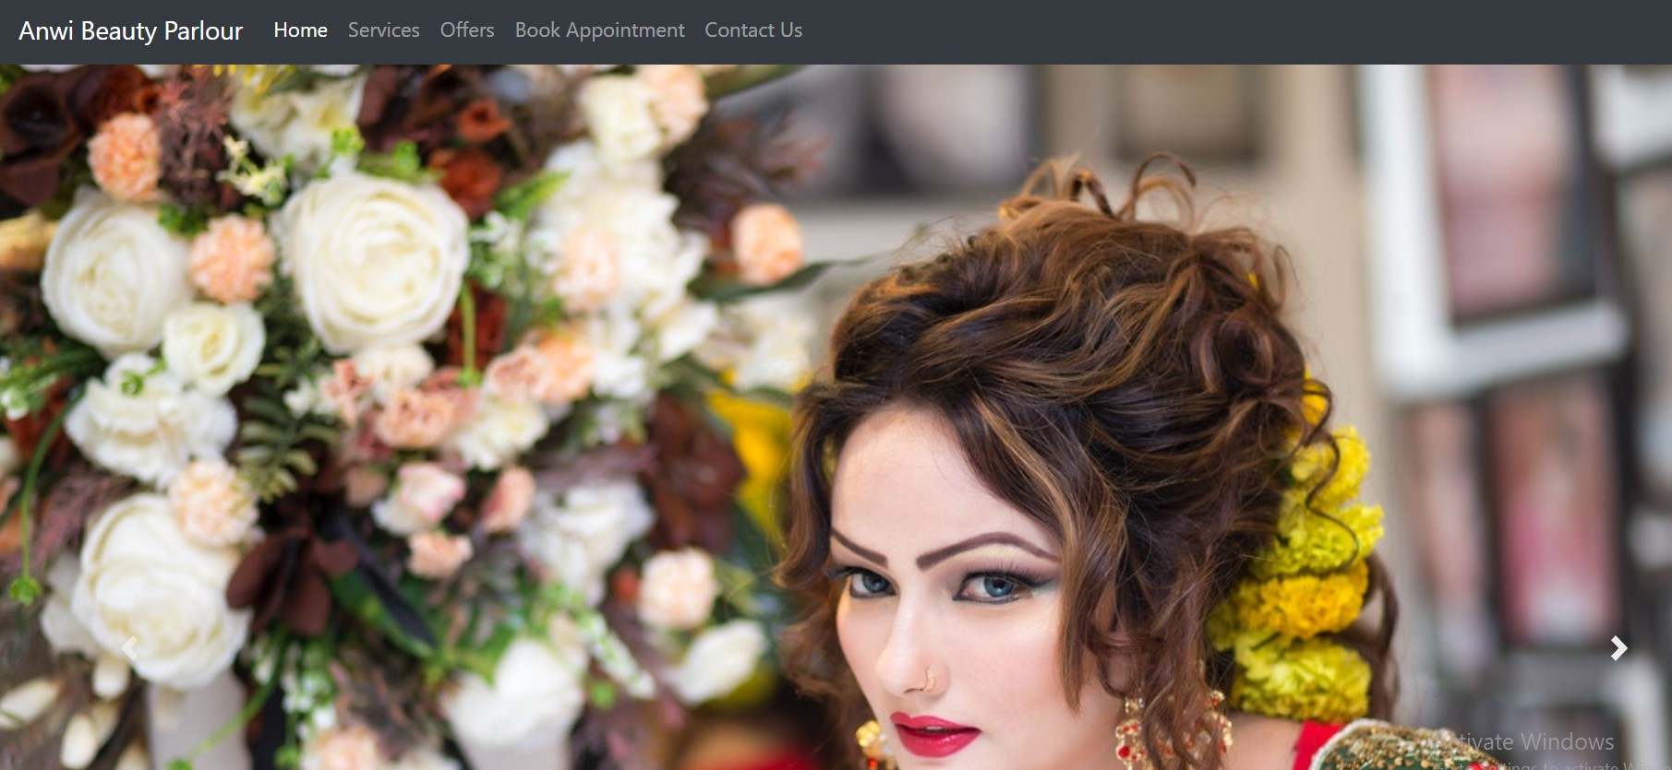

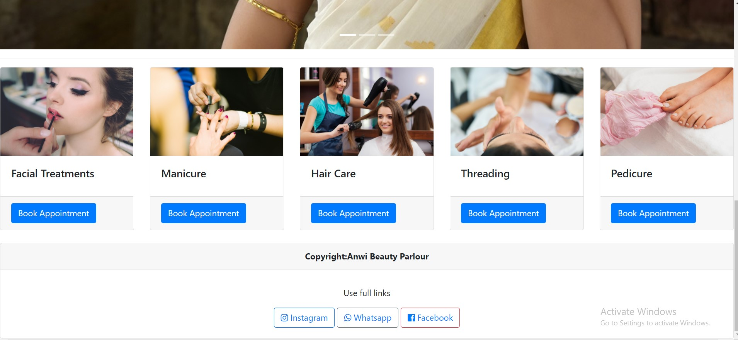

Services Page:

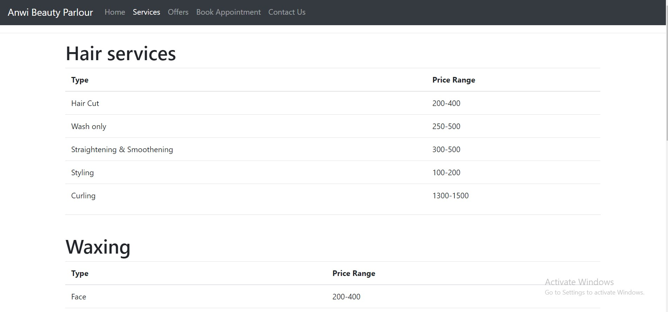

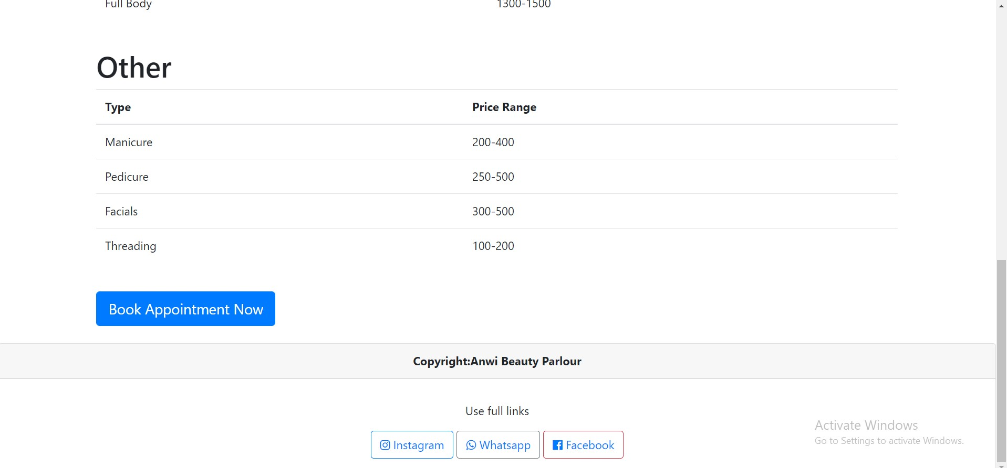

Offers Page:
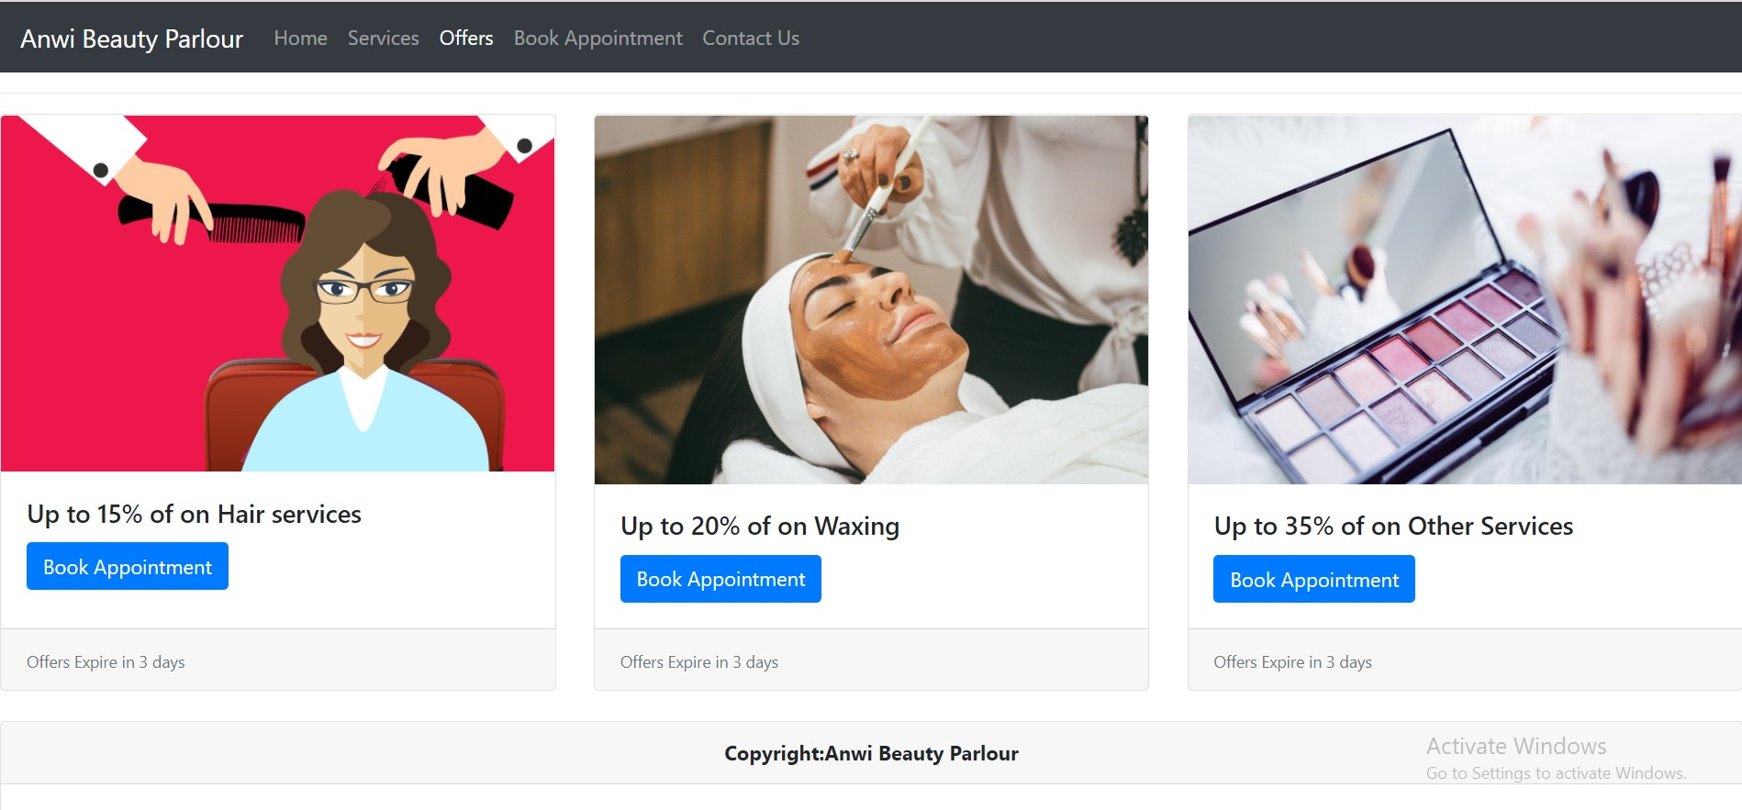
Book Appointment Page:
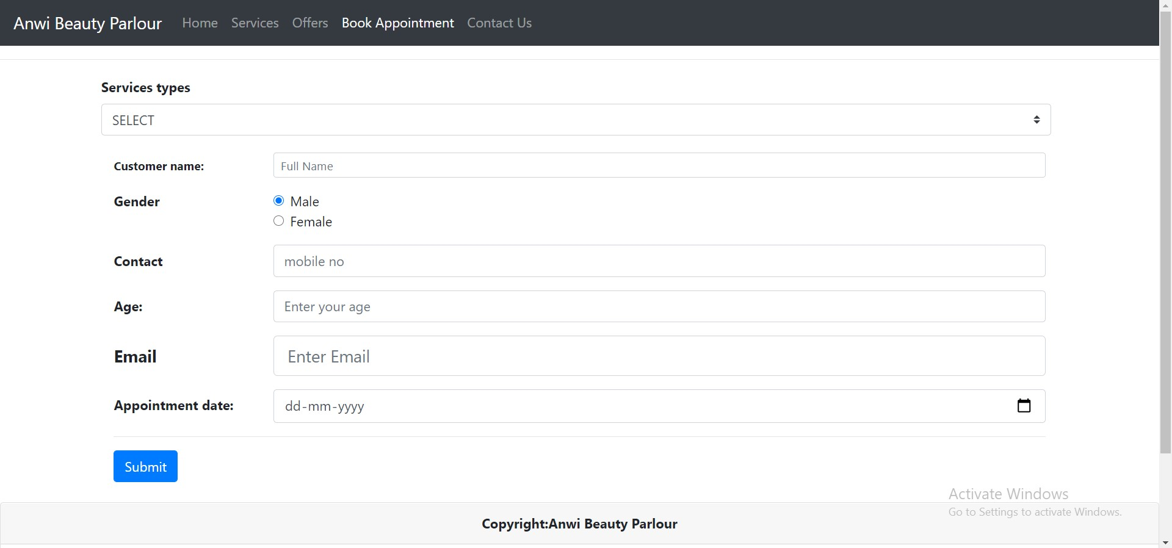

Contact Us
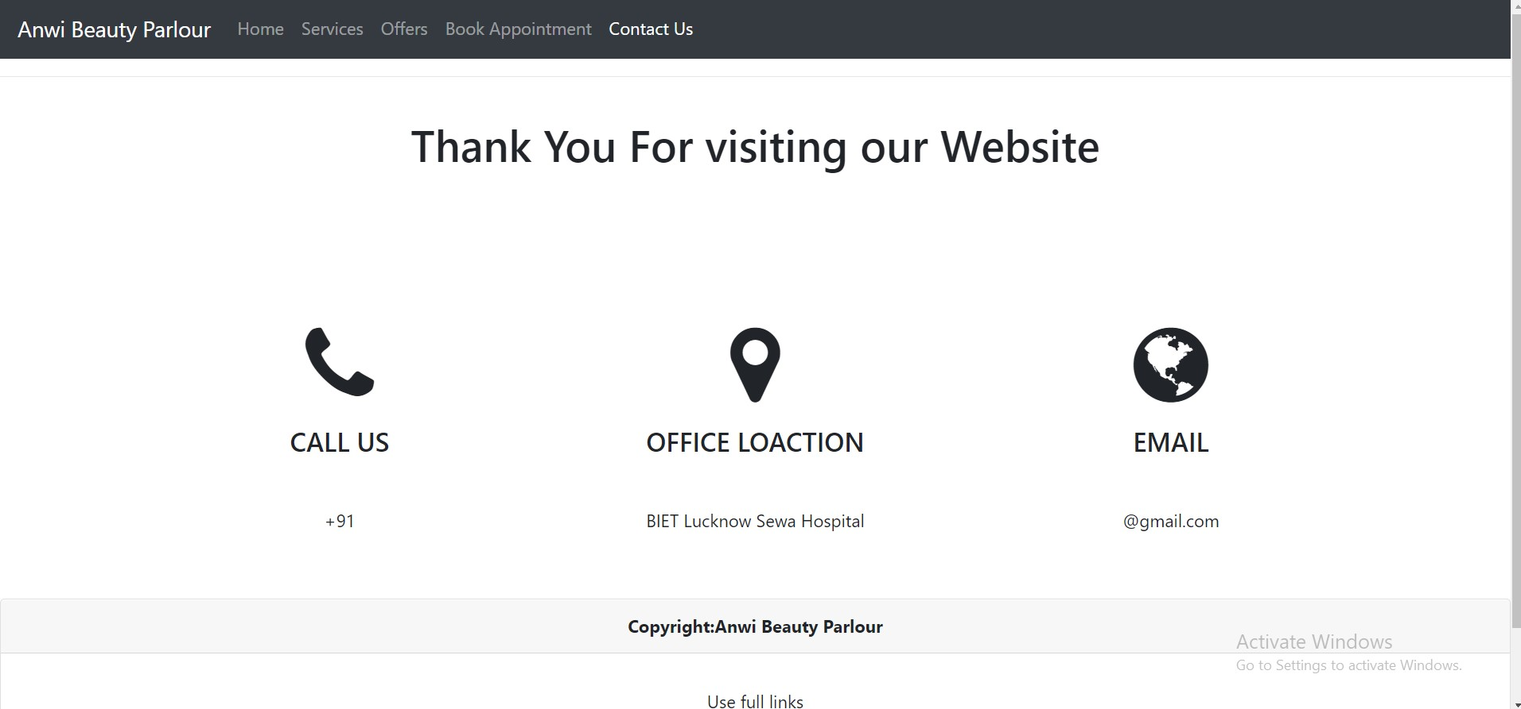
Conclusion of the Anwi Beauty Parlour:

A beauty salon business considered as lucrative business and many individuals may be conscious and nervous in starting their beauty salon business. There are many things to be kept in mind, just like what budget can be afford, which types of equipments, their quality and quantity will be required and about the charge lists of the services can be reliable for one’s business and many other things have to be in mind. It’s a fact that Beauty Salons have a wide business with full competition. The most important thing to get success in this business is to make a fantastic business plan. It’s necessary to make a plan of this business if anyone wants to get success constantly and expand his beauty salon’s business he should make a plan.
Individuals should take always a look on outlook of beauty salon, its presence matters and customer demands. For that the one who wants to open a salon must requires a verified source of study and research about the aspects of this business. To turn out a good business plan into practical, the plan must be strong which prove an exact key of success after applying it. To buy the property individual should conduct market surveys and study the locality comprehensively. Equipments are necessary for salons but before purchasing them individual must carry out a look on price range. The essential equipments for salon are hair styling equipment, washbasins, chairs, hair dryers, manicure & pedicure sets and mirrors to set up salon in its original shape.
While making a purchase keep in mind that many stores offers discounts on equipments for salon and this is the thing to take advantage of such offers but give first preference to quality. These stores provide an opportunity to salon owner to furnish his salons with contemporary equipment. The discount availability varies on bulk purchases. The equipment which has been chosen should have the ability to provide required services. A salon may set in motion only with beauty concern services such as face cleaning, make up, facials, threading and haircuts. Finally, by adding manicures & pedicures services the owner of salon will be able to expand his business with more confident and chances of getting customers.
In conclusion, a good beauty salon production plan gives a suitable idea about the plan for development of business. Furthermore, a well-formulated business plan helps out in search of potential depositor. There is another thing that just planning is not enough; another essential aspect is business plan writing. Individual should search for the help of an expert to write a wonderful business plan that will give you extra edge. The market and challenger information must be a part of a business plan. A fine salon business plan must sketch details such as scheduling nail, styling, cutting and coloring appointments. It should be familiarized information about latest trends in blowing, cutting, drying, and selling hair care products. You should also glance through beauty salons business directories to get plenty of ideas through other beauty salons advertisement, such as if you are going to open a salon in Duncan BC Canada you may take a look at DuncanBusiness Directory to see what they are presenting superfluous things which you have not yet.
The conclusion of this discussion will be bootable for you in this sense if you keep it in your mind ever that beauty salon business plan is a bone for the staff and organization, as it make available a clear outlook of the business plan for the upcoming era. The beauty salon business plan allows you to determine the budget required for the daily service costs. In market individual can judge the position of his company's.

Future Scope of the Project

Career as a Beautician
About Beautician
If you are someone who takes a keen interest in making people look their best then a career as a beautician may be apt for you.
Beauticians are professionals engaged in improving a client’s appearance through hair care, nail, beauty and skin care. Beauticians can often specialize in certain areas such as nail art, makeup application, hair color etc. The responsibilities of a beautician involve recommending different beauty therapies for skin care/hare and a beautician should be experienced when it comes to beauty treatments such as makeup, facial, manicure, pedicure, hair removal, and hairstyling.

Beauticians or beauty therapists have a good understanding of the skin biology and anatomy and they make use of that knowledge to offer non-medical care and relaxation treatments according to the client’s needs and preferences. Some beauticians specialize in a particular kind of treatment such as the spa or permanent hair removal. One needs to have an aptitude or interest in this profession otherwise it can get very difficult. It is an art and those who are thinking of a career in this profession need to have a good aesthetic sense.

Some of the tasks that beauticians perform are as follows

Facial or body massage and treatments such as spa and aromatherapy
Advising/suggesting clients regarding skin and body care
Removing facial or body hair through waxing
Manicures and pedicures
Offering advice on skin care and cosmetic products
Making appointments and maintaining client’s records
To be a successful beautician, there are certain skills that a beautician should have such as being confident when meeting new people, a passion for beauty, artistic ability and a passion for learning new things/trends.

Eligibility to become Beautician
One can get trained to become a beautician after class 12th. There are a number of beauty training schools which offer courses and the duration of such courses is 9-24 months. Hair care, nail care and a lot of other things are taught as a part of the course. People can also choose to get trained on the job, some spas and salons offer training to the employees and a lot of people can also continue to work and get more experience while others may start their own business after getting good experience and exposure.

Types of Job Roles Beautician
Beauticians can choose to work in the following rules:

Make-up artist- Make-up artist is a professional who specializes in just make-up. They work with clients and enhance their physical features for a flawless appearance. A make-up artist can specialize in various techniques such as prosthetics, high fashion, airbrushing, high definition and light blending.

Hair Stylist-Hairstylists are involved in a range of services such as hair colouring, cutting, blow drying, styling etc. They also advise clients regarding their haircare needs.

Cosmetologist- Cosmetologists are experts in facial treatments and can recommend various treatments for skin issues on the basis of skin type.

Nail Care Artists-Nail care artists offer nail services and treatments to clients. This includes manicures and pedicures and also the process of applying artificial nails.

Manufacturing Sales Representative-Sales representatives sell manufacturer’s products to retail and wholesale consumers.

Salon sales consultant-Salon sales consultants are responsible for selling products to consumers in salons. They need to have strong sales skills and an in-depth knowledge of beauty products.

Employment Opportunities for Beautician
Beauticians can choose to work in various settings such as

Salons
TV and film industry
Fitness clinics
In hotels and health resorts
Modelling agencies
Departmental stores
Self-employment
Top Recruiting Companies for Beauticians
Some of the top beauty salons for beauticians are as follows

B Blunt
Geetanjali
Monsoon
Javed Habib Hair and Beauty Salon
Toni and Guy
Affinity
Looks
Lakme
L’oreal
Shahnaz Hussain
Planning to choose Beautician as your career?
Get Expert Help
Pay Scale/Salary of Beautician
The average salary of a beautician is Rs. 1, 82, 035 per year

Books & Study Material to Become Beautician
Some of the topmost beauty books are as follows

An Atlas of Natural Beauty by Victoire De Taillac and Ramdane Touhami
The Makeup of a Confident Woman by Trish McEvoy
Makeup Manual by Bobbi Brown
The Feelgood Plan by Dalton Wang and Kate Faithfull-Williams
Younger Skin Starts in the Gut by Dr. Nigma Talib
Face Paint by Lisa Eldridge
The Make-Up Manual by Lisa Potter-Dixon
Pros of becoming a Beautician
It is a flexible job as not all salons require you to work from 9-5, clients may want appointments over the weekends at times. That way, one can maintain work-life balance.

You get to meet so many new people from all walks of life. It is a profession that gives you the opportunity to become sociable and strike friendship with people easily. You’ll have some clients you’ll get to see on a regular basis and you’ll be able to form a relationship with them.

No matter wherever you are in whichever city, your services will always be in demand. It is a buzzing industry and there is a high demand for both the products and the services.

It is not a monotonous job that way as you’ll get to do a lot of different treatments and that depends on your specialization and the client’s needs.

Cons of becoming a Beautician
One week you may have a really tight schedule and the other week you may not have much work so work is not balanced that way
There are lots of freelancers and there can be stiff competition
The work hours can be very long at times and pay may not be that high
At times, clients may have unrealistic expectations. They may want a particular hairstyle or look and it you’ll probably try to persuade them not to go for it but they may be adamant and want it. That way, once it’s done, they may realize you were right and then find ways to blame you.
It can also be exhausting and you have to be extremely careful as you’ll be dealing with client’s faces and bodies and if something goes wrong, you’ll have to bear the consequences. You have to be careful while using chemicals on clients.
Top Colleges to pursue career as Beautician

Tansen Sangeet Mahavidhyalaya,Delhi

School of Music,Mumbai

Sir J J School of Art,Mumbai

SIR J. J. INSTITUTE OF APPLIED ART,Mumbai

Govt. College of Fine Arts,Thrissur

The Indian College of Arts and Draftsmanship,Kolkata

Natya Institute of Kathak and Choreography,Bangalore

Bengal Music College,Kolkata

Institute of Fine Arts,Varanasi
Paths for Being Beautician
Beautician

Explore Similar Careers
Artist (Fine Arts & Commercial Arts)
Artist (Fine Arts & Commercial Arts)
Content Writer
Content Writer
Explore Popular Career Options
Brand Manager

References and Bibliography:

- Google for problem solving
- https://getbootstrap.com/docs/4.0/
- https://www.tutorialspoint.com/javascript/
- https://www.w3schools.com/html/
- https://www.w3schools.com/css/
- https://www.youtube.com/
- https://stackoverflow.com/

